|  |
| --- |
| NAME: Ayush Vinod Upadhyay  ROLL NO: I025  SAP ID: 60003220131  BRANCH: Information Technology  BATCH: 1 |

**EXPERIMENT NO. 08**

**CO/LO:**

**CO1**- Modify the behaviour of methods, classes, and interfaces at runtime.

**AIM / OBJECTIVE:**

Set up a spring framework and create application using the same.

**PROBLEM STATEMENTS:**

Setup a spring framework in any IDE, and write a program to generate result of students from given marks.

**Code :**

**1)Student class :**

**src/main/java/com/example/demo/model/Student.java**

package com.example.demo.model;

public class Student {

    private String name;

    private int marks;

    public String getResult() {

        return (marks >= 40) ? "Pass" : "Fail";

    }

}

**2) Controlller:**

**src/main/java/com/example/demo/controller/ResultController.java**

package com.example.demo.controller;

import org.springframework.stereotype.Controller;

import org.springframework.ui.Model;

import org.springframework.web.bind.annotation.GetMapping;

import com.example.demo.model.Student;

@Controller

public class ResultController {

    @GetMapping("/generateResult")

    public String generateResult(Model model) {

        // Create a sample student

        Student student = new Student();

        student.setName("John Doe");

        student.setMarks(65);

        // Add student and result to the model

        model.addAttribute("student", student);

        model.addAttribute("result", student.getResult());

        // Return the Thymeleaf template name

        return "result";

    }

}

**3) Thymeleaf Template:**

**src/main/resources/templates/result.html**

<!DOCTYPE html>

<html lang="en" xmlns:th="http://www.thymeleaf.org">

<head>

    <meta charset="UTF-8">

    <title>Student Result</title>

</head>

<body>

<h2>Student Result</h2>

<p>Name: <span th:text="${student.name}"></span></p>

<p>Marks: <span th:text="${student.marks}"></span></p>

<p>Result: <span th:text="${result}"></span></p>

</body>

</html>

**Output:**

**Before execution:**

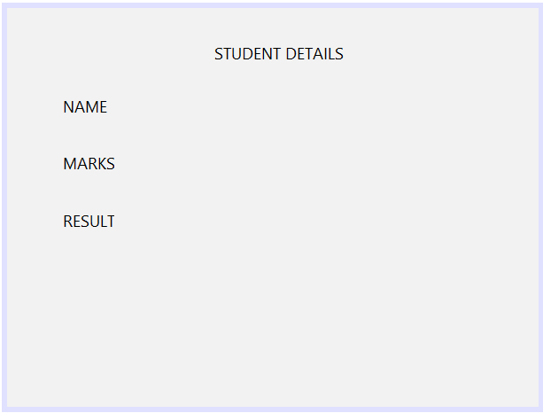

**After execution:**

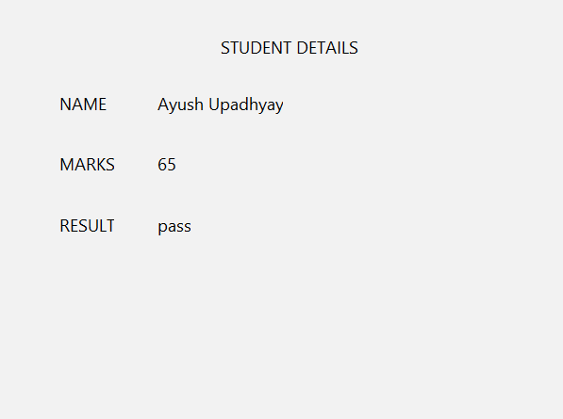

**OBSERVATION:**

The Spring Framework is a comprehensive and widely used framework for Java development, offering a range of features and benefits that make it popular among developers. Here are some advantages of the Spring Framework:

**Modularity:**

Spring follows a modular design, allowing developers to use only the modules that are needed for their application. This modularity promotes a lightweight and flexible development approach.

**Inversion of Control (IoC):**

The IoC container in Spring manages the components of the application, reducing the coupling between classes. This inversion of control simplifies the integration of components and promotes a more maintainable and testable codebase.

**Aspect-Oriented Programming (AOP):**

Spring provides support for AOP, allowing developers to separate cross-cutting concerns such as logging, security, and transactions. AOP helps in achieving cleaner and more maintainable code by modularizing cross-cutting concerns.

**Dependency Injection (DI):**

Spring's DI container simplifies the process of injecting dependencies into components, making the code more modular and easier to test. It promotes loose coupling between components and enhances code readability.

**Abstraction over Low-Level APIs:**

Spring provides abstractions over low-level APIs like JDBC, JMS, and JTA. This abstraction simplifies the development process and promotes consistency across different technologies.

**Data Access:**

Spring's JDBC and ORM (Object-Relational Mapping) modules simplify data access operations. Spring provides support for various data sources, transaction management, and declarative transactions, making database interactions more efficient.

**CONCLUSION:**

We learned and implemented an application with spring framework of java in this experiment and understood the benefits of this framework through the observation.